V.L Memorial Public School
475 Vijay Nagar
Chapter - 14 - Questions - Class8th - Maths
CLASS 08 - MATHS (GANITA PRAKASH)

 | Section A
1 | Two triangles have the same base and lie between the same parallel lines.  Which statement is correct?  a) Their heights are different  b) Their areas are equal  c) Their perimeters are equal  d) Their shapes must be same | [1]
2 | Two rectangles have the same perimeter. Which of the following is always true?  a) Their lengths are equal  b) Their areas are equal  c) Their areas may be different  d) Their breadths are equal | [1]
3 | The area of a trapezium is 84 cm$​^{2}$ . If its height is 7 cm and one parallel side is 10 cm, find the other parallel side.  a) 12 cm  b) 16 cm  c) 14 cm  d) 18 cm | [1]
4 | The diagonals of a rhombus are in the ratio 3 : 4.  If their lengths are 15 cm and 20 cm, find the area.  a) 300 cm²  b) 150 cm²  c) 70 cm²  d) 75 cm² | [1]
5 | A rectangle is divided into two congruent triangles by drawing its diagonal. The area of each triangle is  a) half the area of the rectangle  b) one - fourth the area of the rectangle  c) equal to the area of the rectangle  d) double the area of the rectangle | [1]
6 | The diagonals of a rhombus are in the ratio 3 : 4. If its area is 216 cm$​^{2}$ , find the lengths of the diagonals.  a) 12 cm, 16 cm  b) 9 cm, 12 cm  c) 15 cm, 20 cm  d) 18 cm, 24 cm | [1]
7 | The area of a rectangle is 96 cm$​^{2}$ . If its length is 12 cm, what is its breadth?  a) 8 cm  b) 10 cm  c) 12 cm  d) 6 cm | [1]
8 | The base of a triangle is 20 cm, and its height is 12 cm. Find its area.  a) $200 {cm}^{2}$  b) $240 {cm}^{2}$  c) $100 {cm}^{2}$  d) $120 {cm}^{2}$ | [1]
9 | The side of a square is 15 cm. Its area is ________ cm$​^{2}$ .  a) 200  b) 150  c) 300  d) 225 | [1]
10 | The area of a trapezium with parallel sides 8 cm and 12 cm and a height of 5 cm is  a) $40 {cm}^{2}$  b) $100 {cm}^{2}$  c) $200 {cm}^{2}$  d) $50 {cm}^{2}$ | [1]
11 | A triangle and a parallelogram have the same base and same height.  The area of the triangle is 20 cm².  The area of the parallelogram is  a) 20 cm²  b) 40 cm²  c) 10 cm²  d) 60 cm² | [1]
12 | Find the area of a triangle whose base is 14 cm and height is 9 cm.  a) 23 cm²  b) 126 cm²  c) 63 cm²  d) 45 cm² | [1]
13 | Find the area of a trapezium whose parallel sides are 10 cm and 14 cm and height is 5 cm.  a) 50 cm²  b) 120 cm²  c) 60 cm²  d) 70 cm² | [1]
14 | Find the area of a rhombus whose diagonals are 12 cm and 10 cm.  a) 120 cm²  b) 60 cm²  c) 22 cm²  d) 240 cm² | [1]
15 | The area of a rhombus whose diagonals are 10 cm and 6 cm is  a) $16 {cm}^{2}$  b) $60 {cm}^{2}$  c) $30 {cm}^{2}$  d) $120 {cm}^{2}$ | [1]
16 | Which figure has area equal to$\frac{1}{2}×$ base × height?  a) Trapezium  b) Parallelogram  c) Rhombus  d) Triangle | [1]
17 | Find the height of a trapezium whose area is 84 cm² and parallel sides are 8 cm and 20 cm.  a) 6 cm  b) 5 cm  c) 8 cm  d) 7 cm | [1]
18 | Find the base of a triangle whose area is 36 cm² and height is 6 cm.  a) 12 cm  b) 9 cm  c) 18 cm  d) 6 cm | [1]
19 | Convert 10 in² into cm².  (1 in² = 6.4516 cm²)  a) 45.16 cm²  b) 6.4516 cm²  c) 64.516 cm²  d) 645.16 cm² | [1]
20 | The parallel sides of a trapezium are 10 cm and 6 cm, and its height is 5 cm. Find its area.  a) $80 {cm}^{2}$  b) $60 {cm}^{2}$  c) $50 {cm}^{2}$  d) $40 {cm}^{2}$ | [1]
21 | Assertion (A): The area of a rhombus is equal to half the product of its diagonals.  Reason (R): The diagonals of a rhombus bisect each other at right angles.  a) Both A and R are true and R is the correct explanation of A.  b) Both A and R are true but R is not the correct explanation of A.  c) A is true but R is false.  d) A is false but R is true. | [1]
22 | Assertion (A): If the base of a triangle is fixed, its area will change when its third vertex moves on a line parallel to the base.  Reason (R): The height of the triangle remains the same when the vertex moves on a line parallel to the base.  a) Both A and R are true and R is the correct explanation of A.  b) Both A and R are true but R is not the correct explanation of A.  c) A is true but R is false.  d) A is false but R is true. | [1]
23 | Assertion (A): Two triangles lying on the same base and between the same parallel lines have equal areas.  Reason (R): Such triangles have equal heights.  a) Both A and R are true and R is the correct explanation of A.  b) Both A and R are true but R is not the correct explanation of A.  c) A is true but R is false.  d) A is false but R is true. | [1]
24 | Assertion (A): All parallelograms having the same base and the same height have equal areas.  Reason (R): The area of a parallelogram changes only when its base changes.  a) Both A and R are true and R is the correct explanation of A.  b) Both A and R are true but R is not the correct explanation of A.  c) A is true but R is false.  d) A is false but R is true. | [1]
25 | Assertion (A): A triangle and a rectangle can have the same area.  Reason (R): Figures of different shapes can be transformed into each other by dissection without changing area.  a) Both A and R are true and R is the correct explanation of A.  b) Both A and R are true but R is not the correct explanation of A.  c) A is true but R is false.  d) A is false but R is true. | [1]
26 | Assertion (A): The diagonals of a rectangle divide it into four triangles of equal area.  Reason (R): The diagonals of a rectangle are perpendicular to each other.  a) Both A and R are true and R is the correct explanation of A.  b) Both A and R are true but R is not the correct explanation of A.  c) A is true but R is false.  d) A is false but R is true. | [1]
27 | Assertion (A): The area of a parallelogram depends only on its base and its corresponding height.  Reason (R): All parallelograms having the same perimeter have equal areas.  a) Both A and R are true and R is the correct explanation of A.  b) Both A and R are true but R is not the correct explanation of A.  c) A is true but R is false.  d) A is false but R is true. | [1]
28 | If the base of a triangle is kept fixed and its third vertex moves on a line parallel to the base, what happens to its area? | [1]
29 | The base of a triangle is 30 cm, and the height is 16 cm. Find its area. | [1]
30 | Find the area of a triangle whose base is 12 cm and height is 7 cm. | [1]
31 | A parallelogram has a base of 25 cm and a height of 18 cm. Find its area. | [1]
32 | Convert$96.774 {cm}^{2}$ to in ${in}^{2}$ . | [1]
33 | The area of a triangle and a parallelogram are based on the same base and same height.  If the area of the triangle is 18 cm², find the area of the parallelogram. | [1]
34 | The diagonals of a rhombus are 18 cm and 24 cm. Find its area. | [1]
 | Section B
35 | Find the height of a trapezium, the sum of the lengths of whose bases is 60 cm and whose area is 600 cm$​^{2}$ . | [2]
36 | A rhombus has diagonals of 20 cm and 16 cm. Find its area. If each side of the rhombus is 13 cm, find its perimeter. | [2]
37 | The parallel sides of a trapezium are 14 cm and 10 cm, and its height is 8 cm. Find its area. | [2]
38 | In a four - sided field, the longer diagonal is 108 m. The lengths of the perpendiculars from the opposite vertices upon this diagonal are 17.6 m and 12.4 m, respectively. Find the area of the field. 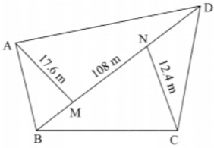 | [2]
39 | A rectangular park is 80 m long and 60 m wide. Find its area. If grass is to be grown at per $m^{2}$ , find the total cost. | [2]
40 | Find the area of a rhombus shaped kite whose diagonals are 16 cm and 12 cm. | [2]
41 | Two sides of a parallelogram are 20 cm and 25 cm. If the altitude corresponding to the sides of length 25 cm is 10 cm, find the altitude corresponding to the other pair of sides. 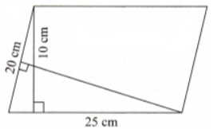 | [2]
42 | A trapezium shaped plot has parallel sides 12 cm and 18 cm. The distance between them is 8 cm. Find the area. | [2]
43 | A rectangular park is 50 m long and 35 m wide. A path of 2 m width runs inside the park along its boundary. Find the area of the path.  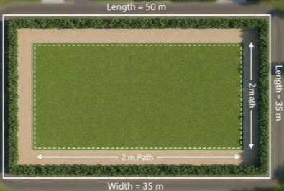 | [2]
44 | What do you think is the area of an A4 sheet? Its sidelengths are 21 cm and 29.7 cm. Now find its area. | [2]
45 | A trapezium has parallel sides of 15 cm and 25 cm, and a height of 10 cm. Find its area. | [2]
46 | Find the area of a triangular piece of cloth whose base is 10 cm and height is 7 cm. | [2]
 | Section C
47 | How do we find the area of this pentagon?  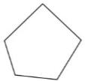 | [3]
48 | Find the areaof the given figure:  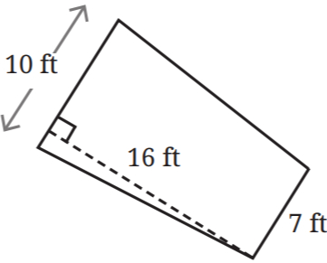 | [3]
49 | The angles of a triangle are in the ratio 2 : 3 : 4. If the triangle has base 14 cm and the altitude from the opposite vertex is 8 cm, find: (3 Marks)  - All three angles  - The area of the triangle  - If another triangle has the same base but half the height, what is its area? | [3]
50 | A rectangular plot measures 50 ft by 40 ft. Express its area in square meters. (Given: 1 ft = 12 in, 1 in = 2.54 cm) | [3]
51 | In the given figure, which triangle has a greater area:$△$ XDC or $△$ YBC, if both the rectangles are identical?  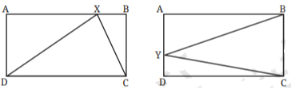 | [3]
52 | A rectangle has length 7 cm and width 4 cm. A diagonal divides it into two triangles. Find the area of each triangle.  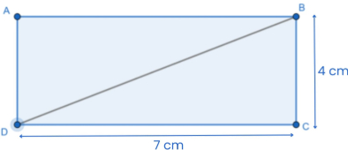 | [3]
53 | A parallelogram and a rectangle have the same base of 12 cm and the same perimeter of 40 cm. A student claims both figures must have the same area. Is this correct?  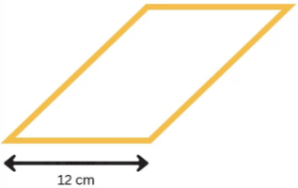  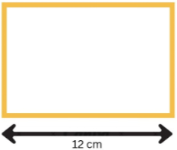 | [3]
54 | Find the area of$△SUB$ , given that it is isosceles, SE is perpendicular to UB, and the area of $△SEB$ is 24 sq. units.  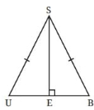 | [3]
55 | A rectangular park is 45 m long and 30 m wide. A path of uniform width 2 m runs around the inside of the park. Find the area of the path. | [3]
56 | Arjun is helping his teacher prepare craft materials for an art activity. He has a square cardboard sheet of side 18 cm. To make decorative pieces, 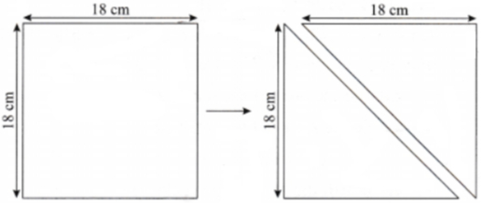  Answer the following questions:  - What is the area of the cardboard sheet?  - Find the perimeter of the square cardboard sheet.  - After cutting the cardboard along the diagonal, what is the area of each triangular piece? | [3]
 | Section D
57 | Read the following text carefully and answer the questions that follow:  A school has a rectangular park used for morning assembly and games. The park measures 30 m in length and 20 m in breadth. To make it more accessible, the school decides to construct a uniform walking path of width 2 m all around the park. The path runs along the outside boundary of the park and surrounds it evenly on all four sides. After constructing the path, the total region (park + path) forms a larger rectangle. The management now wants to calculate the total area covered by the new outer rectangle and the area of the walking path alone, so that tiles can be purchased accordingly. Questions:  - Find the area of the original park. (1)  - Find the dimensions of the outer rectangle after constructing the path. (1)  - Find the area of the outer rectangle. (2)  - OR  - Find the area of the walking path only. (2) | [4]
58 | Read the following text carefully and answer the questions that follow:  For an annual cultural function, a school constructs a large square stage of side 24 metres. To enhance its appearance, a decorative border of uniform width 3 metres is designed along the inside edges of the stage. The remaining central region is used as the main performance area. The organising committee must determine the area of the inner square and the decorative border separately. This will help them decide how much carpet is required for the performance area and how much decorative material is needed for the border. Accurate calculations are necessary for proper event planning and budget control. Questions:  - Calculate the total area of the stage. (1)  - Determine the side length of the inner performance square. (1)  - Find the area of the inner performance region. (2)  - OR  - Calculate the area of the decorative border. (2) | [4]
59 | Read the following text carefully and answer the questions that follow:  In the centre of a public park, a decorative flower bed is designed in the shape of a diamond (rhombus). The lengths of its diagonals measure 30 metres and 16 metres. The gardening department plans to plant seasonal flowers throughout the bed. To estimate the amount of soil, manure, and plants required, they must first calculate the total area of the flower bed. The cost of planting and maintenance is estimated at $₹$ 80 per square metre. Accurate calculation will help in proper budgeting and efficient use of resources for beautification of the park. Questions:  - Name the two measurements required to find a rhombus area. (1)  - Find the area of a rhombus with diagonals 30 m and 16 m. (1)  - If the diagonals of the diamond - shaped flower bed are doubled, find its new area. (2)  - OR  - If the cost of planting flowers is $₹$ 80 per square metre, calculate the total estimated cost for the entire flower bed. (2) | [4]
 | Section E
60 | A quadrilateral PQRS has diagonal PR = 28 cm. The perpendicular distances from Q and S to the diagonal PR are 6 cm and 8 cm respectively. Calculate:  - The area of triangle PQR  - The area of triangle PRS  - The total area of quadrilateral PQRS  - If diagonal QS = 28 cm and the perpendicular distances from P and R to QS are 6 cm and 8 cm respectively, verify that the area remains the same. | [5]
61 | A trapezium ABCD has AB || CD. The diagonals intersect at O. If the area of$△$ AOB is 16 cm² and the area of $△$ COD is 9 cm², find the area of $△$ AOD.  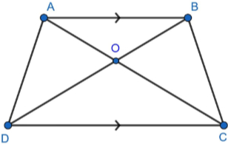 | [5]
62 | A quadrilateral PQRS has diagonal PR = 20 cm. The perpendicular distances from Q and S to diagonal PR are 5 cm and 4 cm respectively.  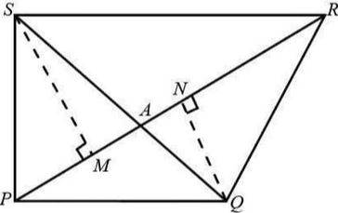  - Find the area of triangle PQR.  - Find the area of triangle PSR.  - Find the total area of quadrilateral PQRS.  - If another quadrilateral has the same diagonal PR but the perpendicular distances are doubled, what will be its area? | [5]
63 | Find the length of the altitude BY.  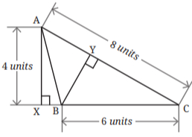 | [5]
64 | Consider a rectangle and a parallelogram of the same sidelengths: 5 cm and 4 cm. Which has the greater area?  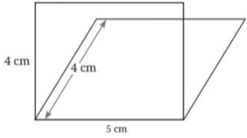 | [5]
65 | Identify the missing sidelengths.  - 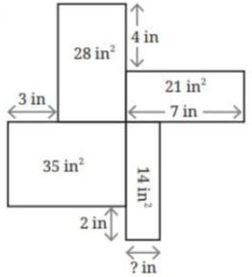  - 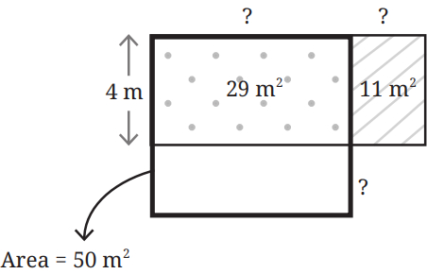 | [5]
66 | ABCD, BCEF, and BFGH are identical squares.  - If the area of the red region is 49 sq. units, then what is the area of the blue region?  - In another version of this figure, if the total area enclosed by the blue and red regions is 180 sq. units, then what is the area of each square?  - 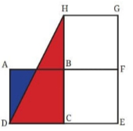 | [5]
67 | State the formula for the area of a parallelogram and explain how it is derived from a rectangle. | [5]
68 | In the figure below, a rectangle lawn measuring 60 m by 40 m has two roads, each 5m wide running in the middle of it, one parallel to its length and the other parallel to the breadth. Find the area of the cross raods.  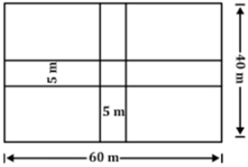 | [5]
69 | A farmer has a trapezoidal field ABCD where AB || CD. The parallel sides are AB = 40 m and CD = 60 m, and the perpendicular distance between them is 25 m.  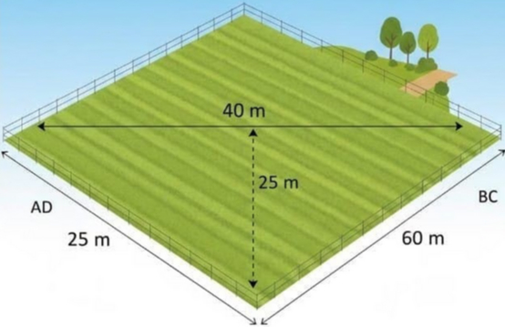  - Find the area of the field in m².  - Convert the area to acres (given: 1 acre = 4047 m²)  - The farmer wants to divide the field into two equal parts by drawing a line parallel to AB and CD. Explain where this line should be drawn.  - If the farmer plants wheat in the field and the yield is 3 kg per m², how much wheat will be produced? | [5]
 | Section F
70 | Fill in the blanks:  - The area of a trapezium depends on its height and the sum of its________.  - The area of a square with side 14 cm = ________ cm$​^{2}$ .  - If two triangles lie on the same base and between the same parallel lines, then their areas are ________.  - The area of a square with diagonal$10\sqrt{2} cm=$ ________ cm $​^{2}$ .  - The diagonal of a rectangle divides it into two ________ triangles.  - The area of a trapezium$=\frac{1}{2}×$ (________ +________ ) $×$ height. | [6]

